

Research Automation Proposal

A Notion-based AI workflow for collecting trusted news, supporting human review, and generating newsletter and media drafts.

Prepared by: Mohammed Abaan

22nd June 2026

1. What will change
The current workflow depends heavily on checking and selecting each source manually, taking notes and then drafting the newsletter and Social Media Script. The new workflow keeps a similar editorial logic, but makes the repetitive parts structured and easier to track. An important point to consider is that AI cannot replace human creativity, judgment, or the unique insights the company provides.
Area | Current approach | Proposed approach
Source monitoring | Team checks commonly used news and research sources manually, using things like Google trends | A scheduled job checks approved RSS feeds, APIs, alerts, and manually submitted links.
Article organization | Useful articles are saved and summarized manually. | Each article becomes a structured Notion record with source, topic, region, date, summary, score, and status, using Notion API.
Article selection | Selection depends on manual judgment spread across notes and links. | Editor reviews a Notion queue and chooses use in Newsletter, SNS Only, Reviewed, or Rejected.
Drafting | Newsletter/script drafts are created with Notion AI supporting the initial draft despite current limitations in control and output quality. | Weekly generator creates first drafts only from human-approved articles, then the editor finalizes.

2. Initial source registry
The first version will start with a curated source registry based on the team’s most used sources and feedback. Each source will be marked with its collection method, credibility level, topic focus, and active status.
Group | Sources
GCC and regional news | Arab News, The National, Saudi Press Agency, Gulf News, Saudi Gazette, Khaleej Times, ZAWYA, Fast Company Middle East, AGBI, Reuters
Global and sector sources | The Guardian International, Nature, Council on Foreign Relations, S&P Global, Smart Water Magazine

Representation Diagrams
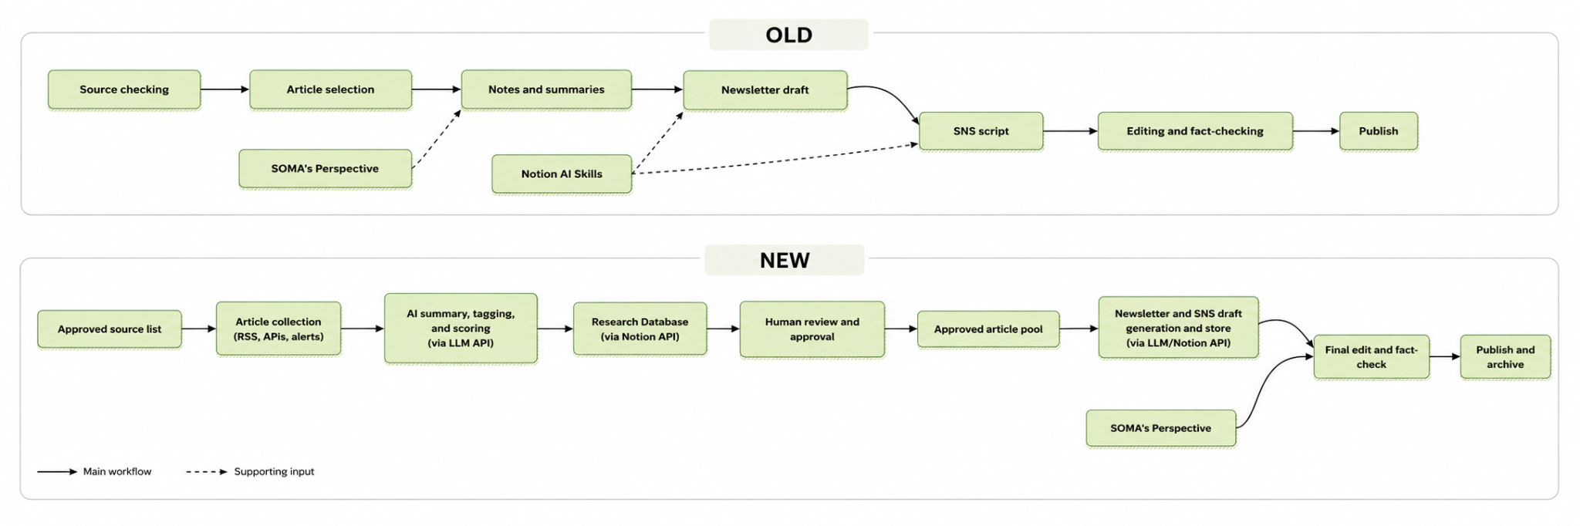
Figure 1. Proposed change from manual article research to a semi-automated Notion-based review and drafting workflow.

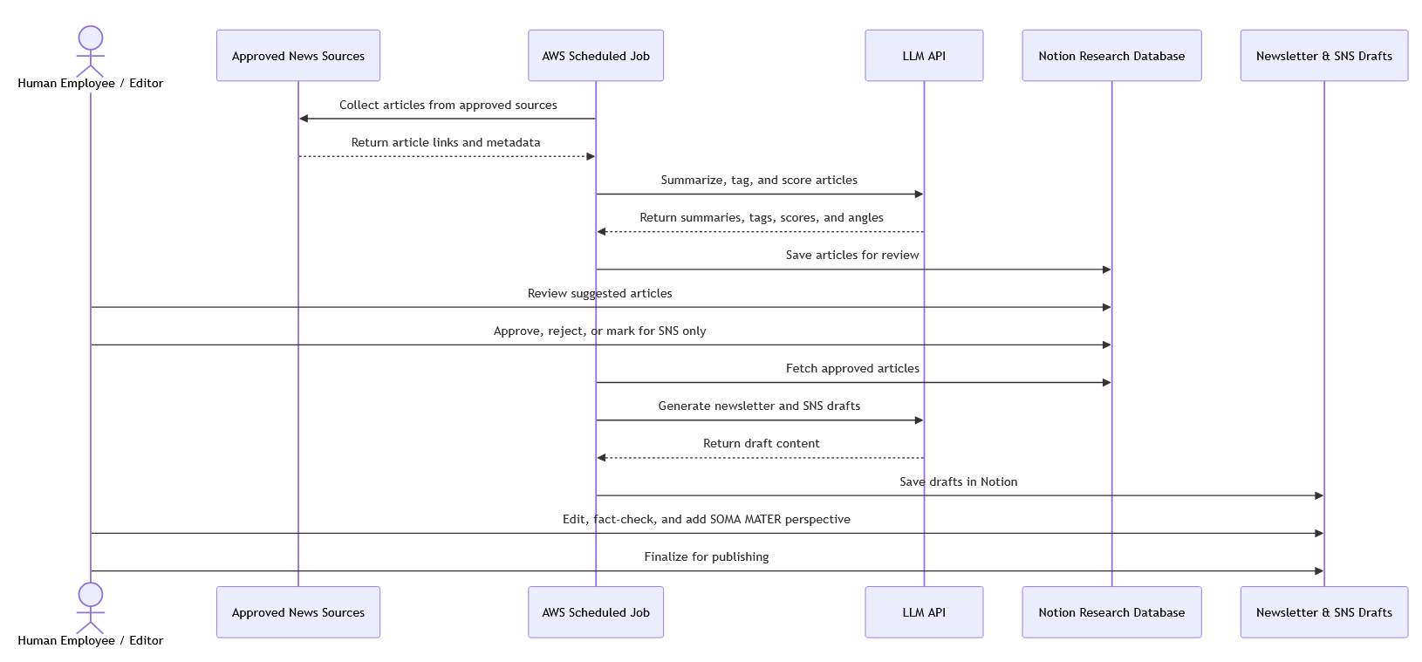

Figure 2. UML Sequence Diagram representing the System Flow and interaction between the actors.

3. Proposed implementation
The system will be built as a small deterministic automation service. In simple terms, this means normal backend code with scheduled jobs, connected to Notion and an LLM API. This is easy to maintain, explainable, and safe.
Component | How it will be used
Python automation service | Runs the article collection, cleanup, deduplication, LLM enrichment, Notion writes, and weekly draft generation.
Notion API | Stores the Research Hub, Source Registry, Review Queue, Newsletter Issues, SNS Drafts, and Prompt Library.
LLM API | Creates source-grounded summaries, tags, relevance scores, newsletter angles, SNS hooks, and first drafts.
Log store | Keeps URL hashes, processing logs, failed runs, and deduplication records.
Scheduler | Runs ingestion daily and draft generation weekly.

The human-in-the-loop article selector will live inside Notion, keeping the review process simple and familiar for the team. AI will collect, summarize, tag, and score articles, but the final selection will remain human-led. Editors will review the suggested articles, choose what should be used in the newsletter or SNS posts, and reject anything that is repetitive, weak, irrelevant, or not aligned with SOMA MATER’s perspective. This ensures the workflow saves time without removing editorial judgment or the company’s own insight.

The AWS deployment will be intentionally lightweight, since the MVP does not require a public website or complex infrastructure. The system can run using AWS Lambda, EventBridge Scheduler, DynamoDB, S3, Secrets Manager, and CloudWatch. For a small workflow using around 15 curated sources, the AWS-only cost should likely remain in the low single digits per month, while the main variable cost will be the LLM API usage. Overall, the expected starting cost is around $10 to $50 per month, although this is only a initial estimate.

4. MVP delivery plan
Phase | Work | Output
1. Setup | Confirm source list, create Notion databases, and define review statuses. | Usable Notion Workspace.
2. Ingestion | Build daily source collection, deduplication, and Notion record creation. | New articles appear in Review Queue.
3. AI enrichment | Add summaries, topic tags, relevance score, newsletter angle, and SNS hook. | Structured article briefs.
4. Draft generation | Generate weekly newsletter and SNS drafts from approved articles only. | Draft pages in Notion.
5. Testing | Test with real sources, tune prompts, document setup, and hand over. | Stable MVP and handover notes.

